What is Amazon SQS?
- Amazon SQS is a message queue service from AWS.
- It lets different parts of your application talk to each other by sending messages.
- Think of it as a mailbox for your apps—one part drops a message, and another part picks it up later.

Why Do We Use SQS?
- Decoupling:
  - Applications don’t need to talk to each other directly.
  - Example: Your website receives an order → puts it in a queue → another service processes it later.
- Smooth handling of high traffic:
  - Messages are stored temporarily if one part of your system is busy.
- Reliable message delivery:
  - Messages are not lost (they stay in the queue until processed).
- Scalable:
  - Works for small apps and very large systems.

Types of Queues
- Standard Queue (Default):
  - High speed and unlimited throughput.
  - Messages may arrive more than once or out of order.
- FIFO Queue (First-In-First-Out):
  - Ensures order of messages is preserved.
  - Each message is processed only once.

How It Works (Simple Example)
- Imagine an online food delivery app:
  - Customer places an order.
  - The order details are sent to an SQS queue.
  - The kitchen (another system) reads the message from the queue.
  - The order gets processed.
This way, even if the kitchen is busy, the orders stay in the queue without being lost.

Key Features
- Fully managed (no servers to manage).
- Pay-per-use pricing.
- Secure: Supports encryption with AWS KMS.
- Integrates with other AWS services (Lambda, EC2, S3, etc.).
1. Open SQS
- In the search bar, type SQS.
- Click Amazon Simple Queue Service.
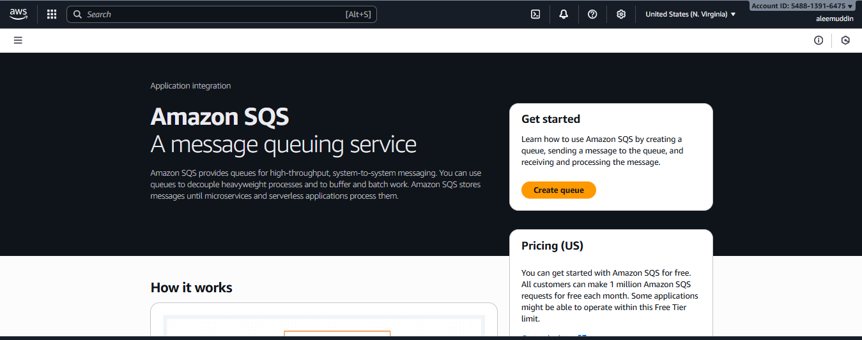
2. Create a Queue
- Click Create queue.
3. Choose Queue Type
- Standard Queue → High performance (default).
- FIFO Queue → Messages stay in order.
- (If FIFO, name must end with .fifo).
4. Set Queue Details
- Enter a name.
- Keep defaults for:
  - Visibility Timeout (30s)
  - Message Retention (4 days)
- Click Next.
5. Encryption (Optional)
- Enable Server-Side Encryption (SSE) if you want extra security.
6. Access Policy (Optional)
- Keep default or allow specific AWS accounts/services.
7. Dead-Letter Queue (Optional)
- If needed, set a DLQ for failed messages.
8. Review & Create
- Check settings → Click Create queue.
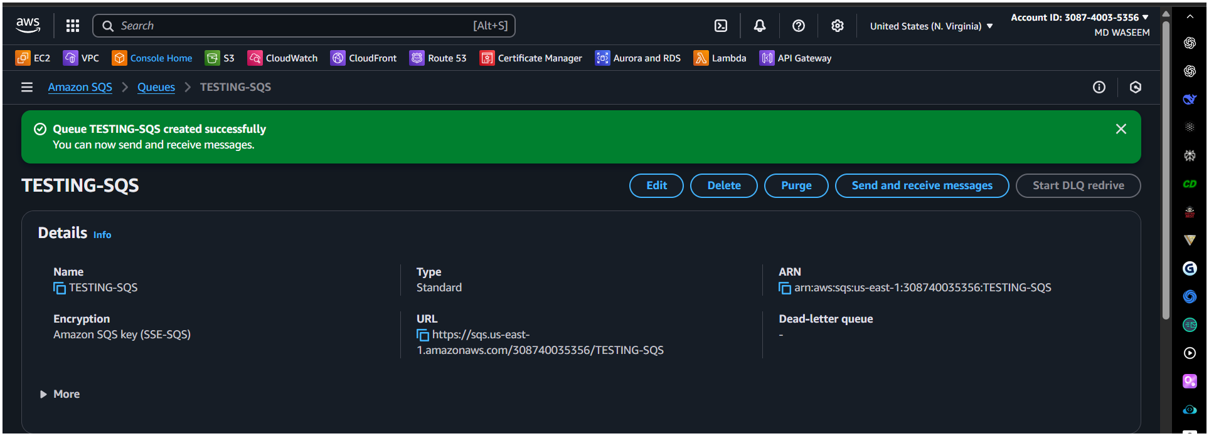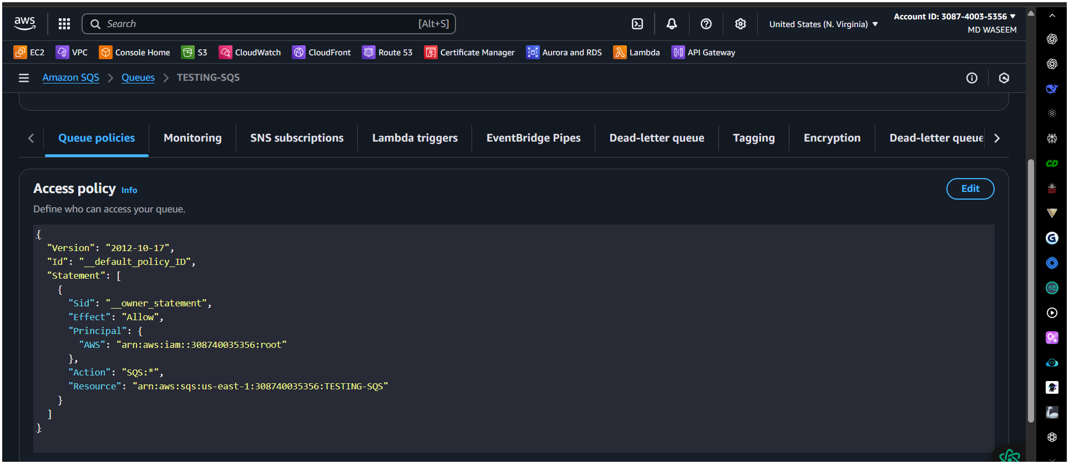
9. Queue Ready
- Copy Queue URL.
- You can now send/receive messages via:
  - AWS Console
  - AWS CLI
  - AWS SDK (e.g., Python boto3)

What is Amazon MQ?
Amazon MQ is a managed message broker service. It helps different applications send messages to each other reliably, using popular protocols like ActiveMQ or RabbitMQ.
Think of it like a post office for applications—one app sends a message, and another app picks it up later
Steps to Create an Amazon MQ Broker
- Open Amazon MQ Service
  - Go to AWS Console.
  - In the search bar, type Amazon MQ, and click it.
- Click “Create Broker”
  - This starts the process of setting up your broker.
- Choose Broker Engine
  - Select:
    - ActiveMQ (older, feature-rich, stable).
    - RabbitMQ (lightweight and modern).
- Set Broker Details
  - Name: Give a name to your broker (e.g., MyTestBroker).
  - Instance Type: For example, mq.t3.micro (small and cost-effective).
  - Deployment Mode:
    - Single-instance: Simple setup (good for testing).
    - Active/Standby: High availability (good for production).
- Authentication (Login Details)
  - Create a username and password for connecting to the broker.
- Network Settings
  - Select:
    - VPC (your virtual network in AWS).
    - Subnets (where the broker will run).
    - Security Groups (control access, like firewall rules).
- Encryption (Security)
  - At rest: Data is encrypted automatically using AWS KMS.
  - In transit: TLS encryption enabled by default.
- Logging & Maintenance (Optional)
  - You can enable CloudWatch Logs to monitor activity.
  - Set a maintenance window if needed.
- Review and Create
  - Check all settings.
  - Click Create Broker.
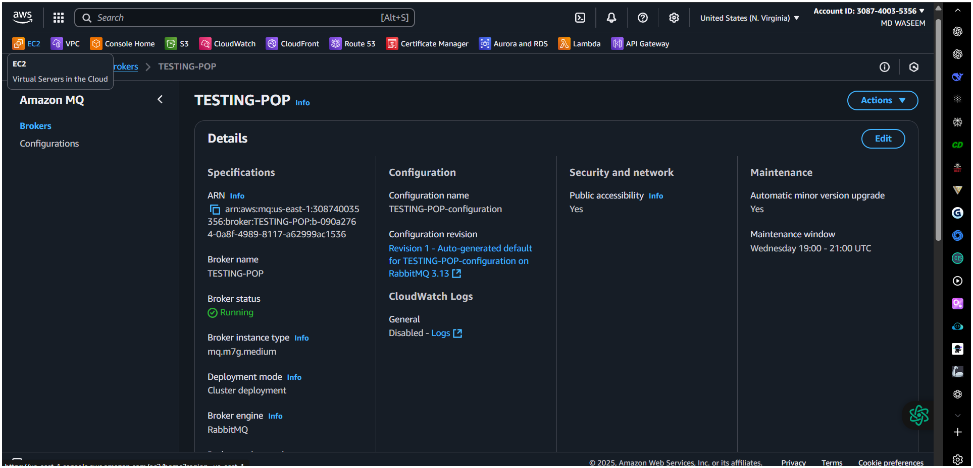
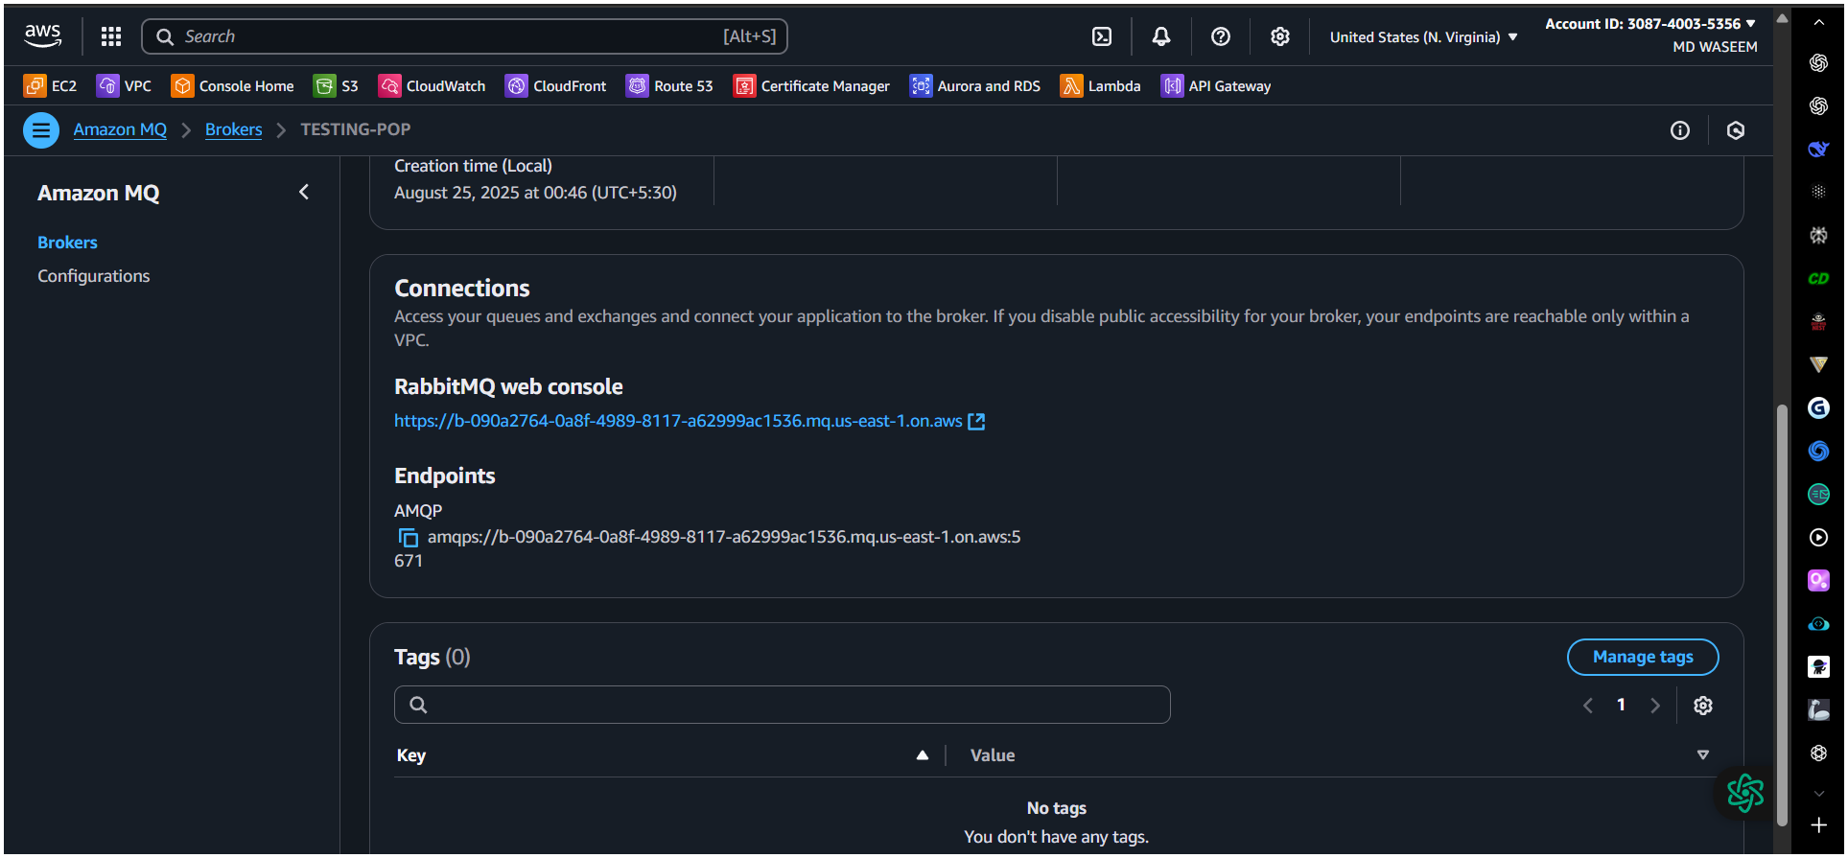

- Connect Your Applications
  - After creation, you’ll get broker endpoints (URLs) to connect apps.
  - Use protocols like AMQP, MQTT, STOMP depending on your chosen engine.

